**Name: ............................................ ID……………………………………**

**Periodic Table**

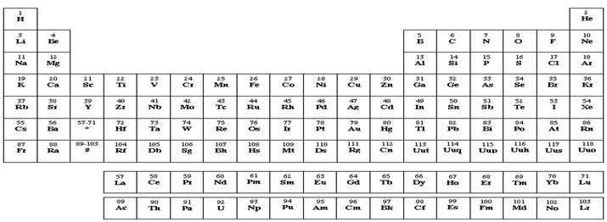

1. **(5 points)** Complete the Lewis structure for the simple organic molecule whose skeletal structure is shown below. Add multiple bonds and lone pairs as needed BUT NO ADDITIONAL ATOMS. Then survey the sigma, pi and lone pairs. Place the number of each in the blanks supplied.



In this structure there are:

1. _____ sigma bonds
2. _____ pi bonds and
3. ____ lone pairs.
4. Upload the Complete the Lewis structure here:

(insert figure here)

2. (**5 points)** Based on the skeletal structure please answer the following questions.



How many valence electrons are needed in the Lewis diagram of the inorganic compound whose skeletal structure is shown above?

__________ e-‘s

b. Now complete the Lewis structure here:

(insert figure here)

c. With the help of the Lewis structure please answer the following questions:

Regions _________ Regions with bonds _________

Shape __________________________________

1. **(5 points)** If the electronegativity of fluorine is 4.0 and that for Cl is 3.0, what kind of bond forms between F and Cl? Use a  e. n. calculation to justify your answer. Write yes/No inside the (…..) area.
2. ionic (...) polar covalent (......) nonpolar covalent (....)

1. overall, this molecule is: polar (......) nonpolar (...........)

Explain why: _________________________________________

* **(3 points)** Draw a picture of an CCl4 molecule showing bond angles, hybridization, all bonding orbitals and lone pairs.

(insert figure here)

5. (**2 points)** How do you identify ionic bonds in any compound? Show examples.